Ministry of Environment, Solid Waste Management and Climate Change

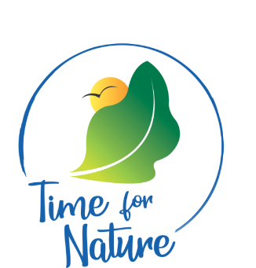

Environmental Awards

2023

Guidelines for Participation
– Finance Sector

1.0 Introduction
With increasing environmental awareness and consciousness, various local institutions are taking sustainable and best environmental initiatives to inter-alia, reduce their carbon footprint, optimise use of resources and curb down the environmental nuisances. These efforts need to be encouraged, recognized and awarded.

The aim of the Environmental Awards is to recognise the best environmental initiatives and reward efforts of the finance sector on sustainability measures and also encourage their replication for a cleaner, greener and safer Mauritius.

2.0 Categories for the competition
2.1 Banking
This sub-category will include all commercial banks and those licensed by the Bank of Mauritius.

2.2 Non-Banking
This sub-category will comprise institutions licensed and regulated by the Financial Services Commission and includes Insurance, Global Business, Wealth Management, Fund Management, Stockbroking and Asset Management companies, Private Pension Schemes, Credit Finance, Payment Intermediary Services, the Stock Exchange of Mauritius Ltd etc.

2.3 Professional Services
This sub-category will include Audit and Accounting institutions and legal and consultancy firms.

3.0 Assessment Criteria for the 3 categories:
- In-House Operations
- Products
- Certification and Reporting
- Outreach and engagement with the community
- Motivation to participate in the competition (250 words)

4.0 Submission and Selection
- Participants should submit the duly filled participation form, to this Ministry via email on awardfinance2023@gmail.com at latest 02nd May 2023 by 16:00 hrs.
The form will be available on the website of:
(i) Ministry of Environment, Solid Waste Management and Climate Change (https://environment.govmu.org).
(ii) Bank of Mauritius (https://www.bom.mu/ )
(iii) Mauritius Bankers association (https://mba.mu/ )
(iv) Financial Services Commission (https://www.fscmauritius.org/en )
(v) Mauritius Finance (https://mauritiusfinance.com/ )

- During the screening exercise, candidates may be requested to provide additional information on their initiatives.

- Shortlisted candidates will be notified by 2nd week of May 2023 for an interview exercise with the jury panel.

- The Ministry will produce a short video clip that will be viewed at the gala night. Selected candidates will be kindly requested to facilitate the shooting of the video clip.

5.0 Award
Your participation in the competition will be an opportunity to showcase nationally, the commitment of your organisation towards a sustainable Mauritius.

The winners for each category (one winner and two runner-ups per category) will be announced during the Awards Ceremony to be held in the context of the World Environment Day Celebrations on Monday 5th June 2023.

For any further clarification, you may contact the Department of Climate Change, Ministry of Environment, Solid Waste Management and Climate Change on Tel: 203 6200 (Ext:327) or 2089224

